The Happy Sheet

September 2015

Sunset to Starry Night Sail
Friday, September 11 7-10 pm
The new moon is due on the thirteenth, so there will be next to no moon on the 11th. If we get lucky and the skies are clear, we will have the best star show possible! Member and guest event.

The Big Water Boat Swap
Sunday, September 20th 10 am
One boat will leave from Lexington and the other from Southshore. The boats will meet in the Sandy Beach area, have a break and change crews. If you get on Number 9 in Lexington you will return to Lexington on Rusty. This will achieve the boat swap required without all the car pool driving complications.
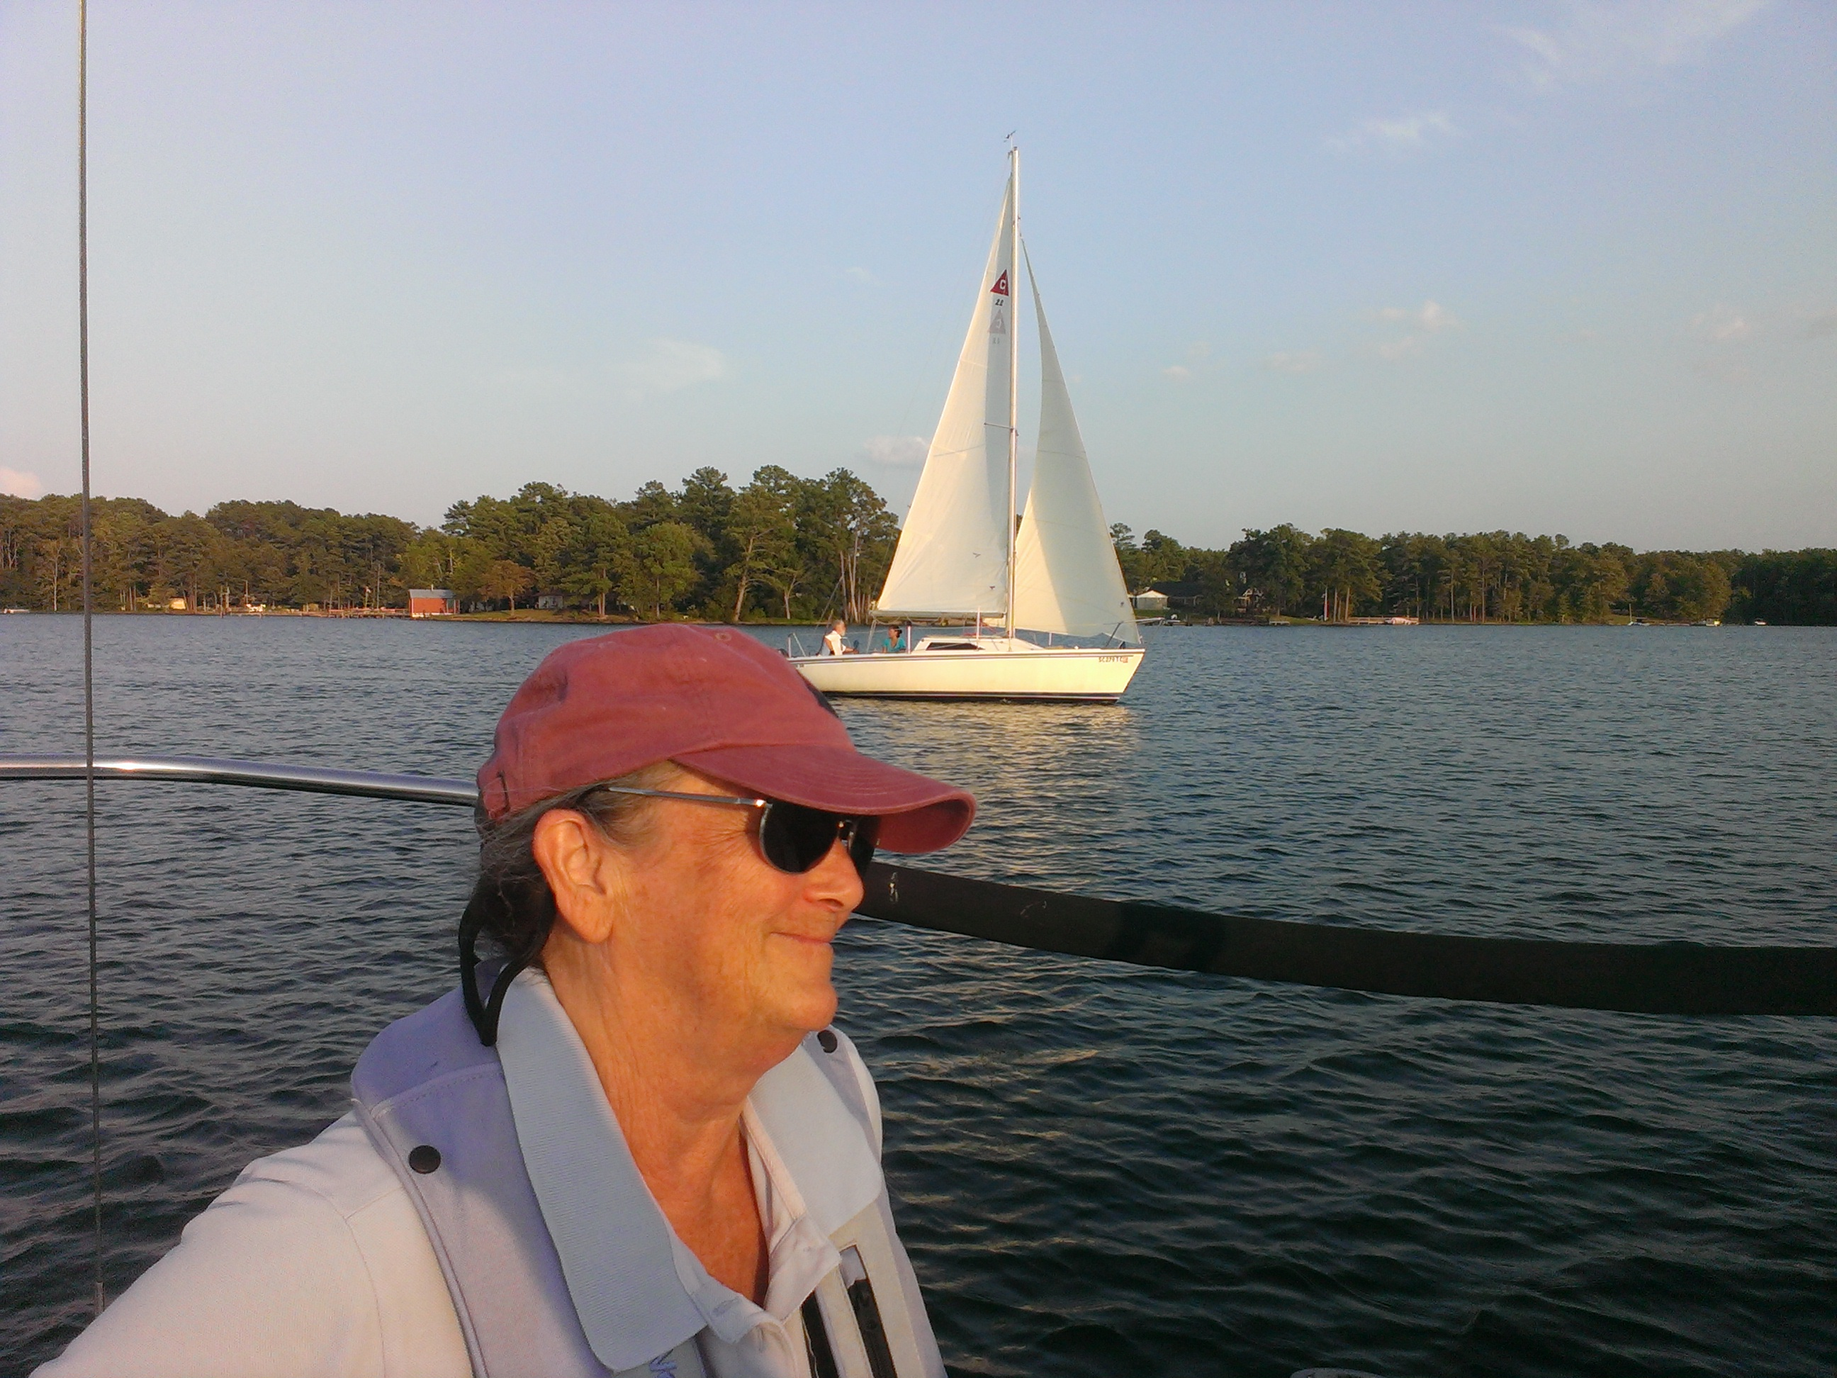

Tuesdays with Murray are officially done for this year, but if anyone wishes to continue (starting at an earlier time) let us know and we will email it out. The pictures are from the last one that had all three boats out.

The Charleston Trip is full! If you have a destination for a future charter where you’d like to sail, be sure and let us know. We will probably be looking for a week in the summer and a few days in the fall.
Fickle Engines and the Benefits of the Happy Sails Club!
No classes were scheduled one day recently so Brian was going to take a day off. He stepped outside (the best weather forecasting method) and saw that the wind and temperature were perfect for a brisk sail across the lake and back. The throttle handle had fallen off the engine he had, but a pair of vice grips should have done the job temporarily… well darn the engine gears had locked up as well, so no joy there! While trying the vice grip engine there had been calls about the engine on Barbara Ann not starting! It should not have been a problem as it had been serviced within 2 weeks and Brian had started it on Thursday! Rusty was available so the club member used her instead. That meant Brian could use his skills to get the engine working on Barbara Ann and still get a sail in! Wrong again; it was a good idea, but the engine would not start! For Brian the moral is don’t take a day off because it breaks engines, for Happy Sails Club members the moral is don’t own a boat when you can sail ours and we deal with the hassles of engines in the shop!

(Post Script: Brian gave up on the sailing day when he tripped getting off Barbara Ann (step out, then off, dummy)… very occasionally it is safer to sit on land and let a day go by peacefully.)

Eve of Halloween Sail
Friday, October 30th 7:30-10:30 pm
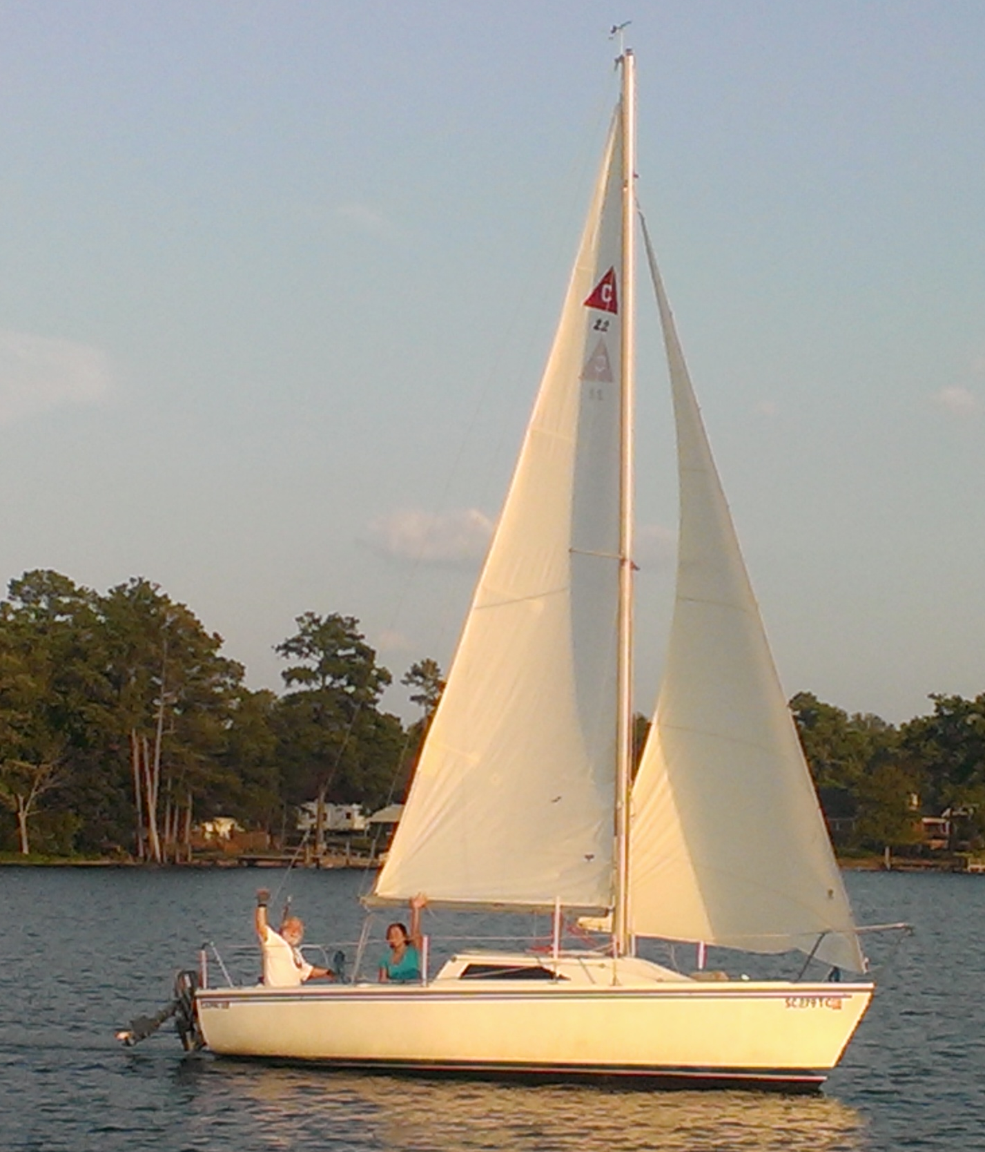
The search for the early pumpkin! The Great Pumpkin dropped his cousin in the lake a day early so we need to rescue it! Bring your witches brew and come in your not overly elaborate costume for a night sail on Wilana. We will sail beyond the One Red Eyed Winking Monster of Harbor Watch that lurks in the trees past Neil’s Island of Hell on route to the lost pumpkin of Magic Hollow Creek!

Tip of the Month
Sit down to pee and/or wipe the head! The head on Wilana (and all boats we’ve been on) is weenie so aiming is not always a good idea. Gentlemen don’t be proud: sit down and you’ll never miss and the splash back is minimized! Skippers, please include a wipe down of the special little room to your end of cruise clean up!

