The Happy Sheet

June 2014

Let's Go Sailing – Memorial Day Weekend
The pictures are from our mixed bag of sailors for Let's Go Sailing. We had old friends and people who had never sailed before come to enjoy a sail! We even had a couple of people on their first date! Saturday’s wind was different too: 10-12 in the morning to just about zero for a couple of hours and back up to 5-10 for the evening!

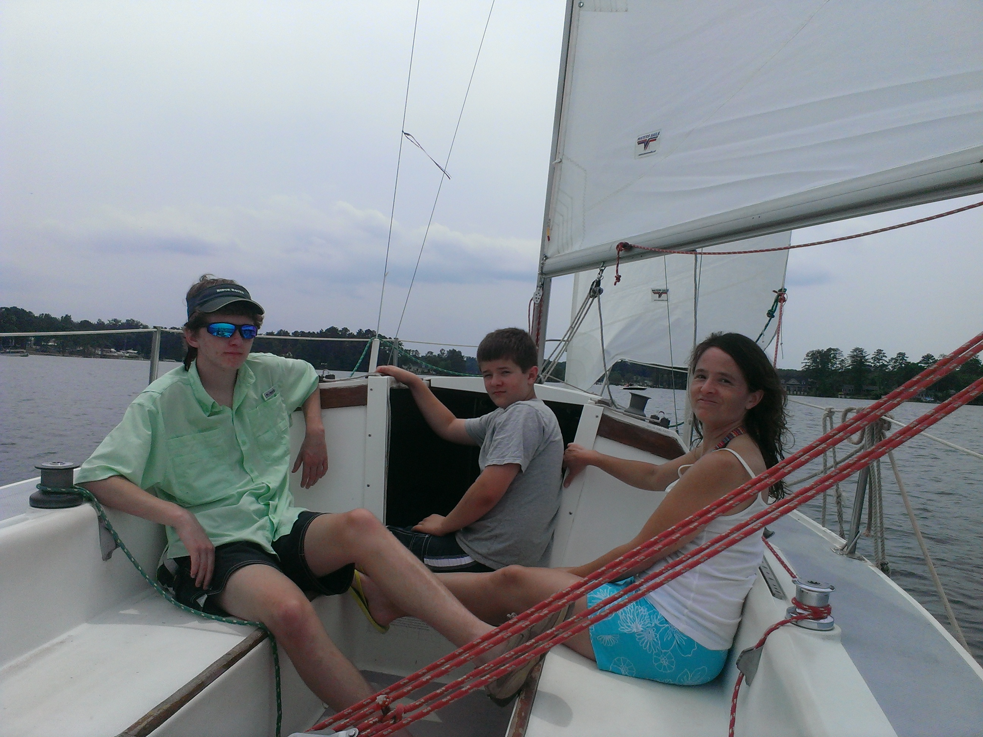
Tuesdays with Murray
Through June 24 6 pm - sunset
We’re taking advantage of having the Helms 27, so it's wheel and diesel sailing on Tuesday evenings in June. The sails can also be check out sails with Brian.

Freaky Friday Sunset Sail
Friday, June 13th 6:13-9:13ish
Is it safe to sail on Friday the 13th? Member and victim sail. Bring your lucky charms!

De Novo Through the End of June
We still don't know what De Novo means, but we have a feeling it has to do with new stuff! For the Helms 27 that would be new head to main sail, new main sheet, new batteries, and newly repaired throttle! We get to keep her through June. It does mean that one of the other boats may be out of circulation for odd periods as we take advantage of the extra boat for some repairs to the others.

Don’t forget the following rules for using De Novo:
-No single handing.
-You will want help docking and departing.
-ASA 103 or comprehensive check out by Brian qualifies you to use it.

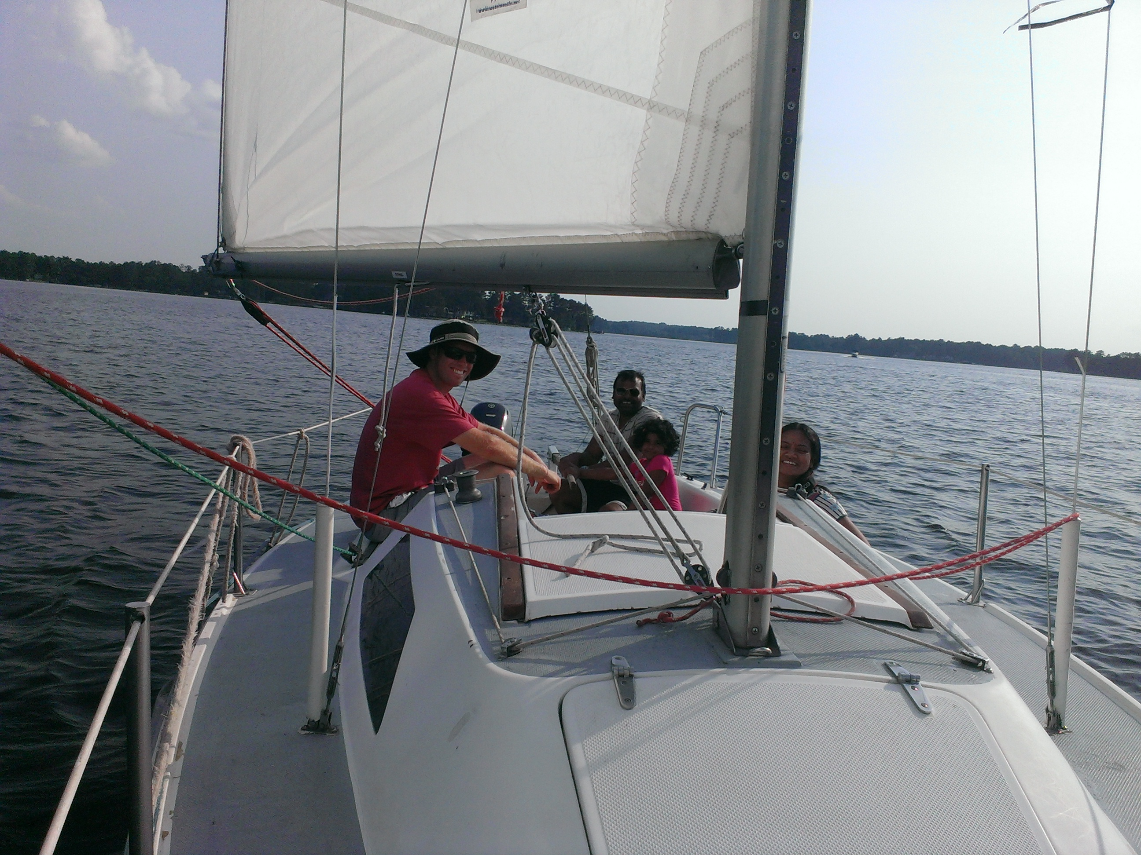
Flag Day and Other Landmarks June 14, 7-9pm
Brian celebrates his first American birthday and his 50th overall on Flag Day! What’s more American than hotdogs and beer? Not much, so he's inviting friends to share a beer and a hot dog at our dock on the peninsula from 7-9 pm. Please let us know if you are coming and bring a chair!

July 4th
The Lake Murray Fireworks will be on June 28 this year. We will be open as usual during the day but would like all boats back by 7:00 pm as all the crazies will be heading out around then! We don't want to put you or the boats in harm’s way during the fireworks.
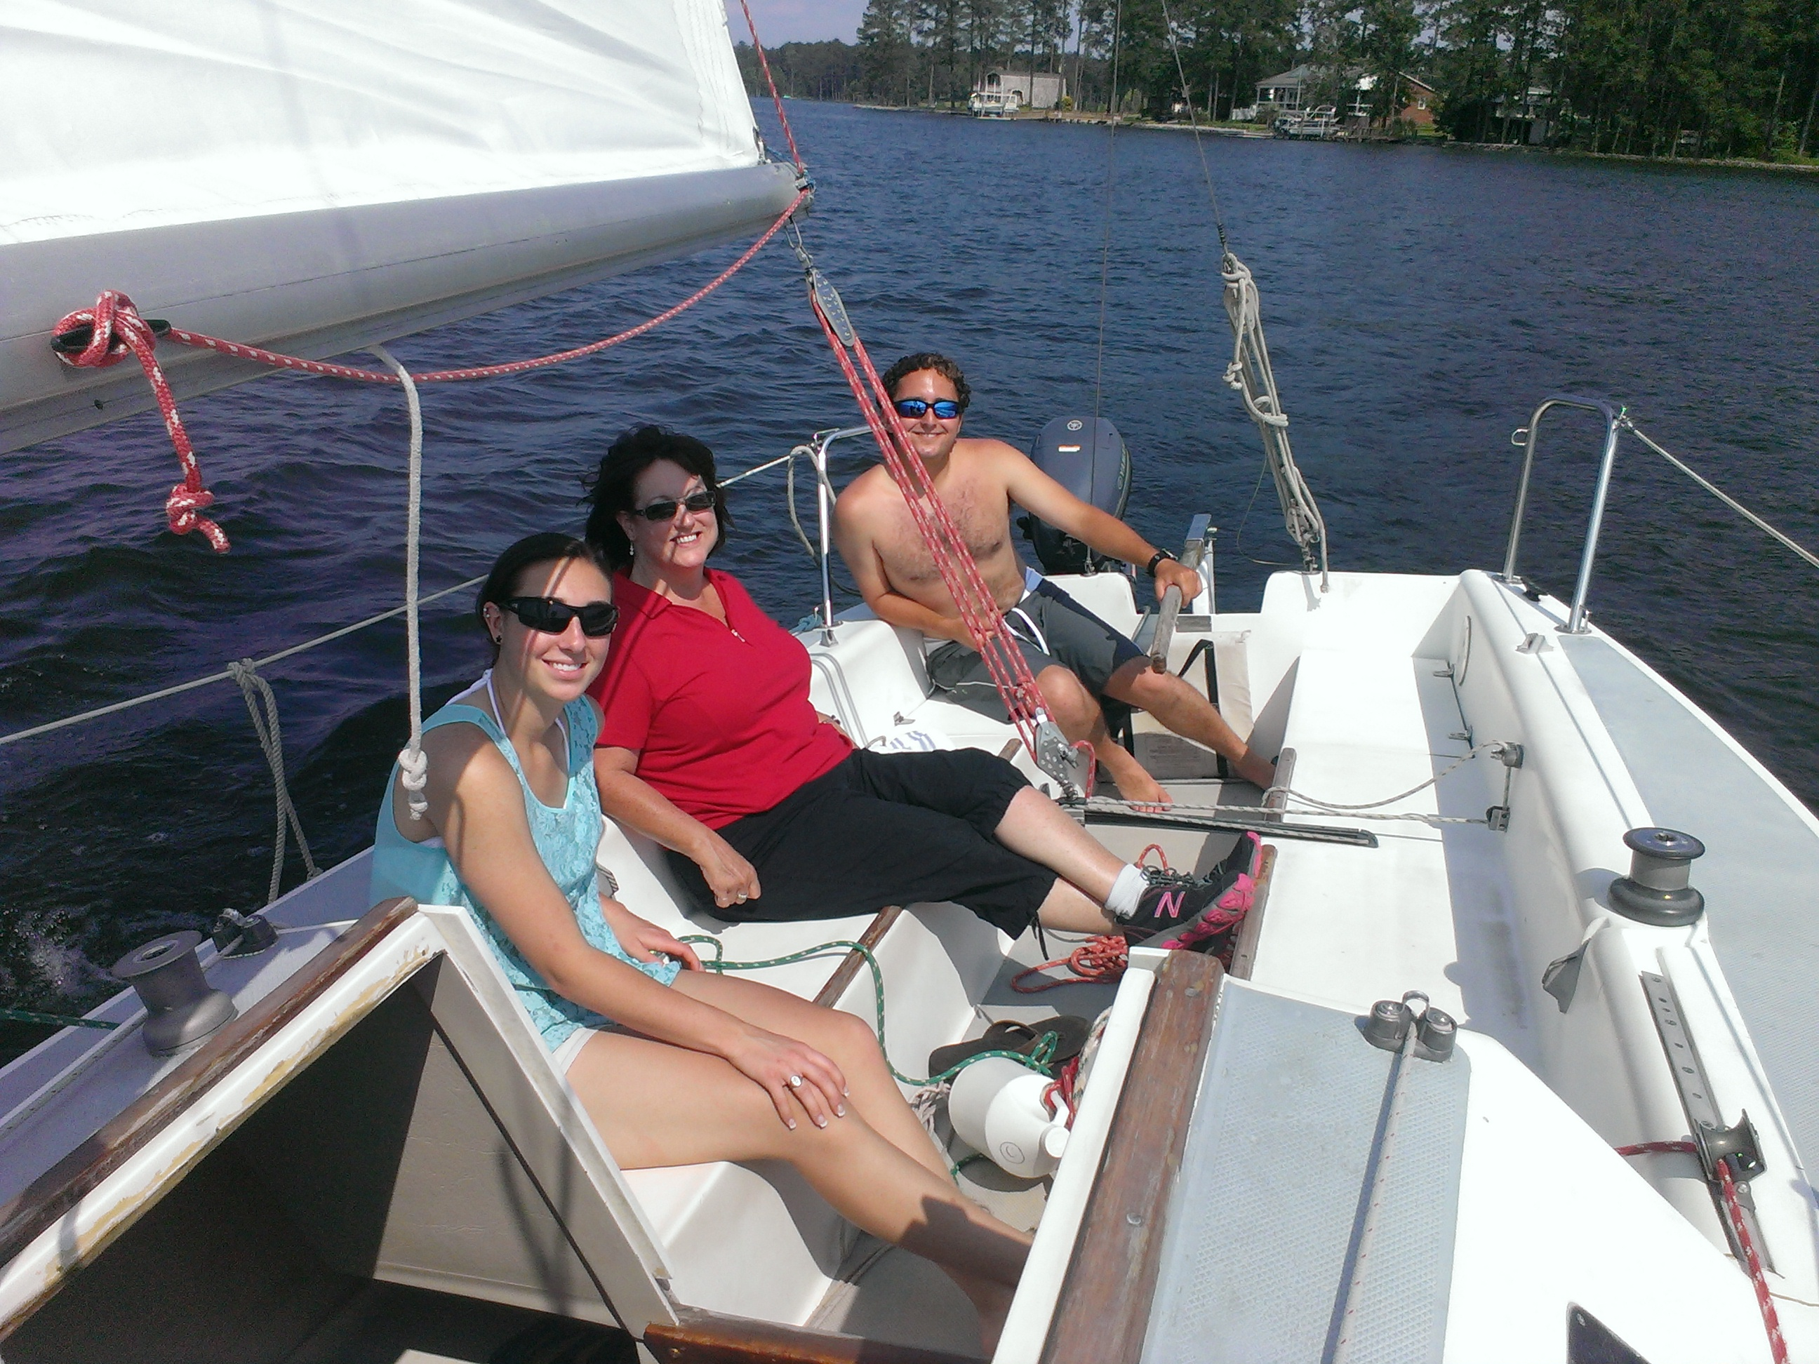
We will be doing a Let's Go Sailing event over the July 4 weekend on Friday the 4th, Saturday the 5th, and Sunday the 6th.

Full Moon Sail
Saturday, July 12 7:00-11:00pm
The lake by the light of the full moon is a cool place to be after a hot July day! We'll catch the sunset and moonrise on a bigger boat! Member and guest event.

