August 2013

Thanks to Al and Lisa for some special contributions to the Happy Sails Club!

What do Point Judith Light and Block Island actually look like?
Those of you that have taken Coastal Navigation (ASA105) have seen these places on the practice charts, but what do they look like in full up close and personal color? Lisa went on a charter in the area and then generously took time to put together the power point in the link. Here is her email that she attached the link to: “Here is a link to the powerpoint through dropbox. You are free to pass this on to others. Mostly, I circled places on the chart then showed what they look like from the boat, along with some other stuff. The charts are best viewed in full screen (slideshow), but if you view in regular edit mode, there are some notes.”
https://dl.dropboxusercontent.com/u/106233467/Rhode%20Island%20Nav.pptx

Again, thanks to Lisa. I will be using it during Coastal Nav 105. We are very likely going to offer that class again in October. I will also pass it on to the ASA instructor’s forum on Facebook.

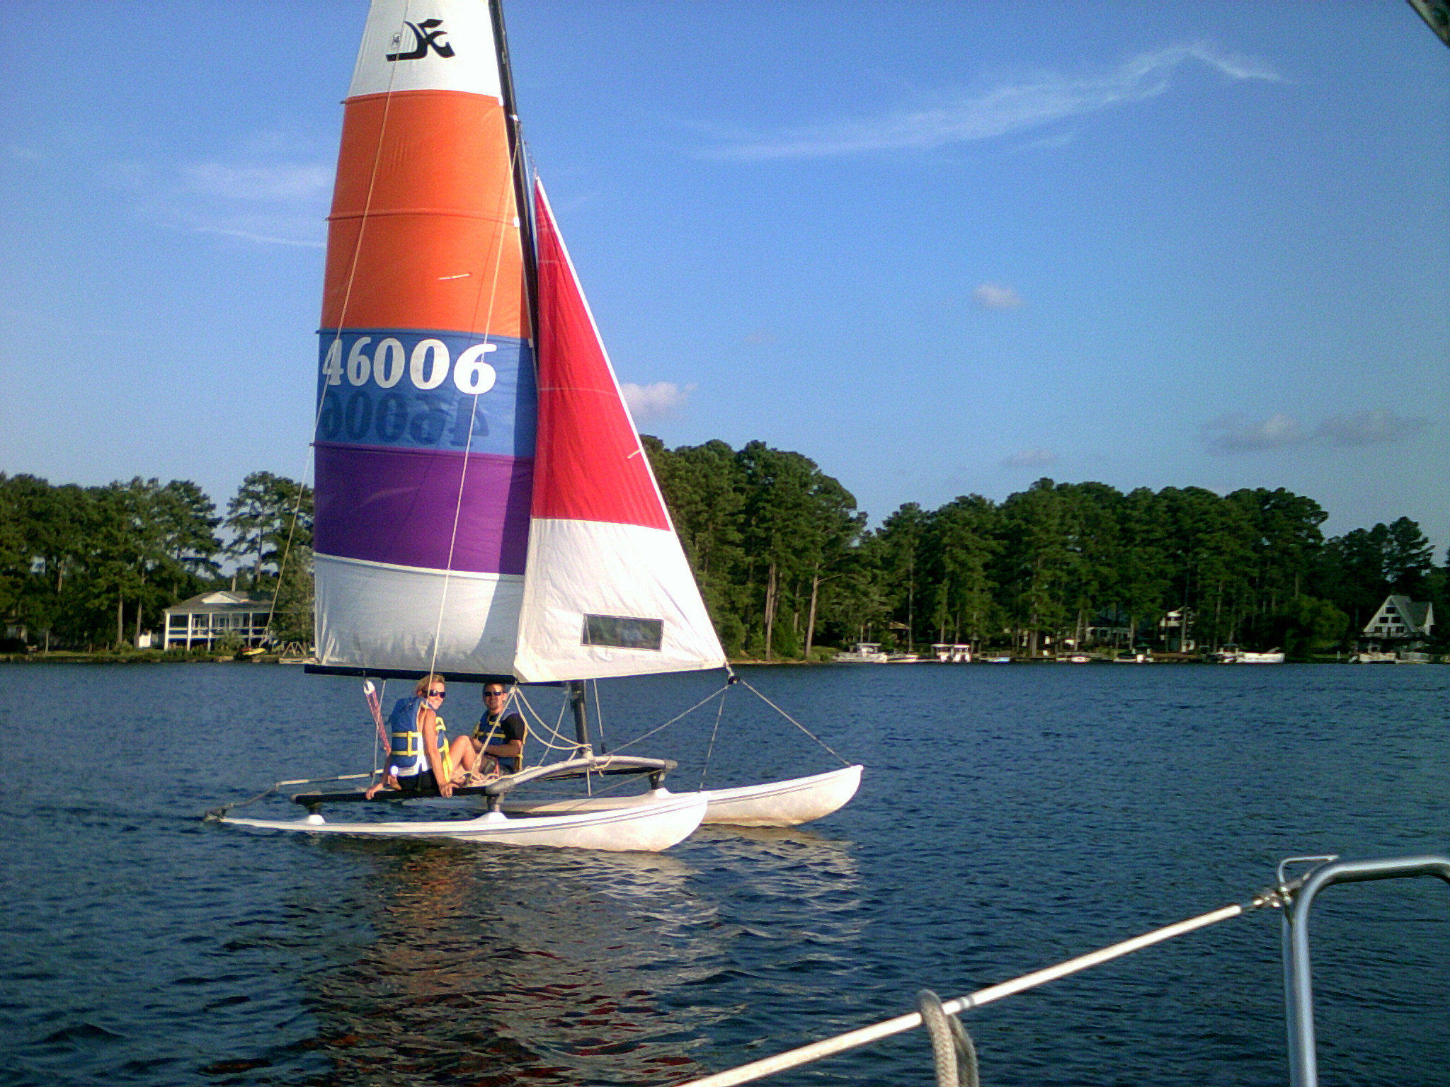
This Month’s Pictures are of Al’s Hobie Cat 14 Turbo!
Many people ask if we have beach cats for rent and we say no and explain the difficulty getting to and from the dock to water that we can sail in. Al generously lent us his Hobie Cat for some fun and to test the theory. The pictures show the fun and as for the getting it to and from the dock, one club member summed it up: “It is a fun boat but it is begging for a beach!” The Hobie will be around for a short while unless it gets sold first!
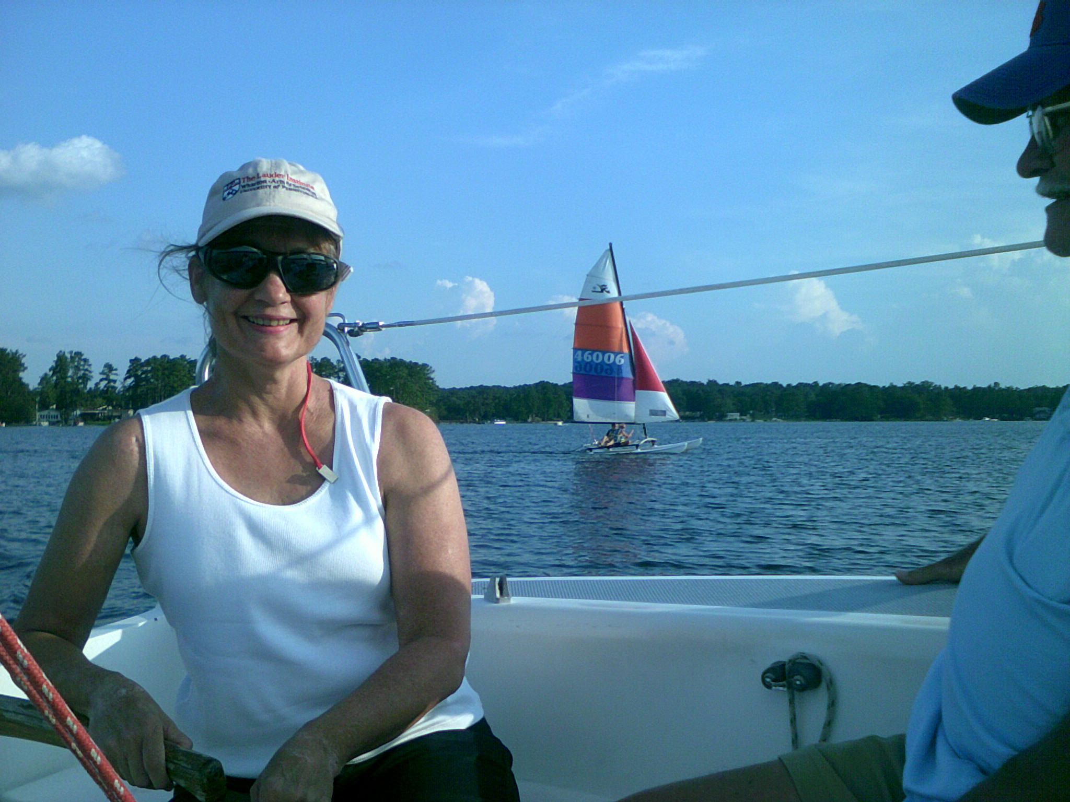

Purple Martins on Bomb Island: August 3, 5:30-11:30 pm
This is a long trip from Southshore, but it’s worth it! Bring food and drinks and even your swimsuit if you are so inclined! It’ll be on Wendy Lee! We will endeavor to not take any wrong turns this year!

Perseid Meteor Shower Dawn Sail, Sunday August 11, 3:30am
Bring your Krispy Kremes and coffee! As it is likely to be quite warm overnight we are trying a different approach this time. We will meet at the dock at 3:30am, yes 3:30am, go out and try and find a dark spot on the lake to check out the building meteor shower and sunrise. If the breeze is nice we will sail for the morning and back to Southshore by about 12:00 for an afternoon nap. If you wish to camp out on the boats the night before let us know. http://earthsky.org/astronomy-essentials/everything-you-need-to-know-perseid-meteor-shower
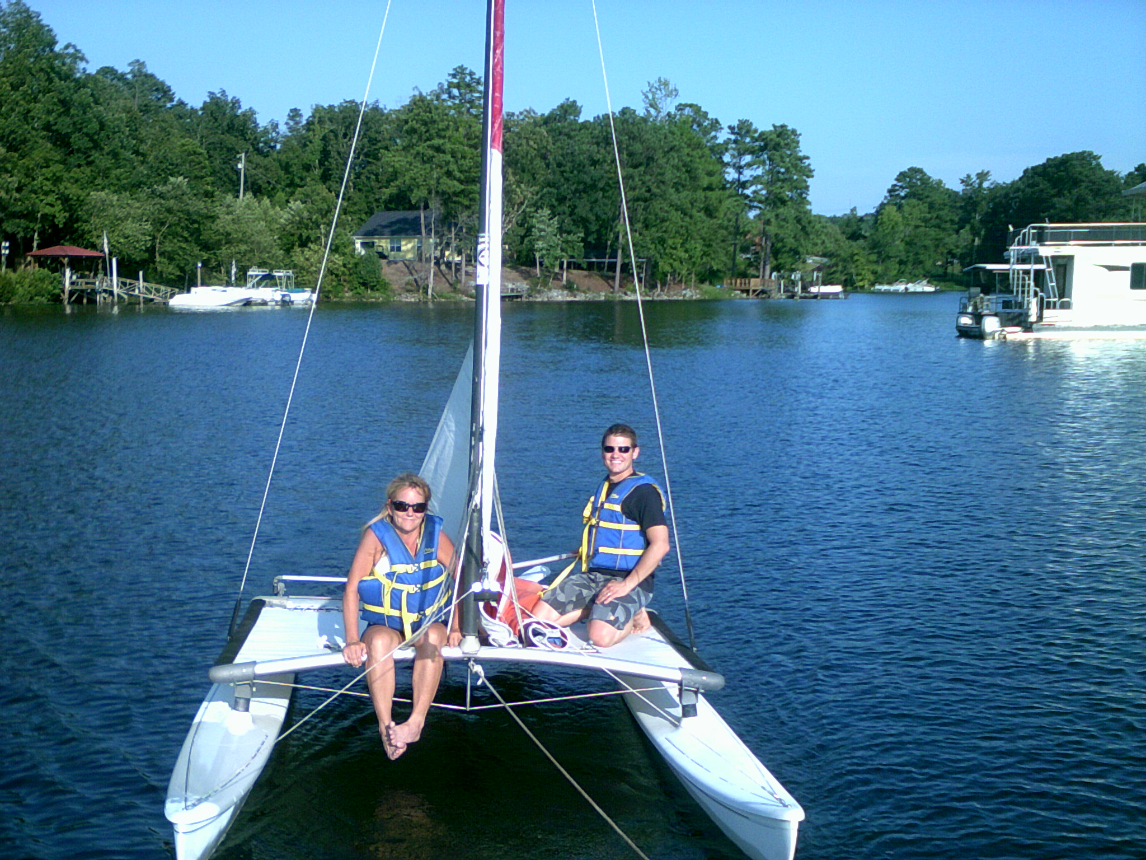
Workaholic Wednesdays! August 7, 14, 21, and 28, 6:00pm till we are done!
In the same vein as “Tuesdays with Murray” and “Thirsty Thursdays” we will try different things depending on conditions and participant choices! It is a very pleasant midweek break that Brian enjoys. No stress sailing with friends!

Let’s Go Sailing Labor Day Weekend, Aug 31, Sept 1 and 2
After curtailed Let’s Go Sailing events for Memorial Day and July 4th we are going full on for Labor Day weekend. We will do 4 sails a day with up to 4 guests per sail! If you would like to try your hand at hosting 4 complete strangers on a boat for 2 hours, let us know. It is a relatively painless way to see if you like the idea of instructing! This link gives more details https://www.facebook.com/events/170966089742112/

Sunset to Moonlight Sail September 14, 2013 6:00 - 9:00 pm

Fantasy Land: BVI’s Spring Break 2014, March 8-16
UPDATE: We have 2 very interested people. We are going to spread the word further afield from now, so if you are interested and want to be penciled in please let us know ASAP. We may well be looking for a small deposit around October 1st. This will be a “No Classes just Cruising” trip. Just a bunch of friends going sailing! The dates correspond with USC Spring Break. Depending on numbers and boat size, etc. we estimate a high end price would be $1500 per person, not including flights. This would include on board daytime food etc., but not “adult beverages” or dinners. If we get lucky that number may be as low as $1100. We will be offering it to Happy Sails Club members, former students, family and friends! Please get on board with this as early as possible!

