The Happy Sheet

December 2016

It is hoped that you are recovering from a great Thanksgiving and looking forward to a smashing Christmas! There was a break from our normal turkey sandwich sail but we do have a Polar Hangover Bloody Mary Bear Sail!..........

Sail and Ale, December 17, 2016
1:00-4:30 at the Lake and post sail ale at Keg Cowboy in Lexington Last club group sail of the year. We have no affiliation but have found Keg Cowboy to be very relaxed with a different menu and nice beer selection.
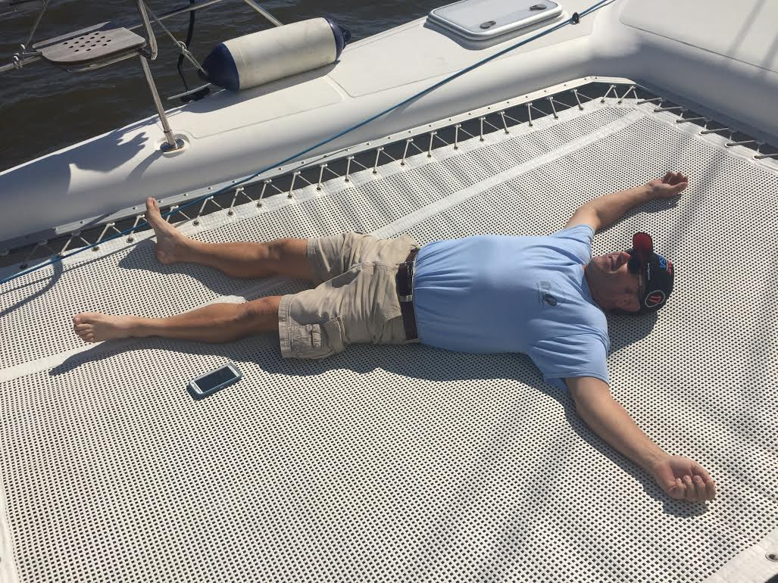
Polar hangover bloody Mary bear sail, January 1st 2017, 9-4ish
We’ll sail to the Frayed Knot or Liberty Tap room for a refreshment of our choice and back. It’ll be a longish sail so wear your warm stuff.

Chinese New Year Sail, January 28, 2017 1:00-4:30
I am going to sailing PC dog house for this but it’s time for a jibing clinic!

Fall Sailing Trip (Oct 29, 30, & 31) Update
80 degrees was great! A little more wind would have been handy! Learning a bunch about big catamarans doubled the experience! I relaxed (see the picture)! The other pictures were from Art’s collection from the trip.
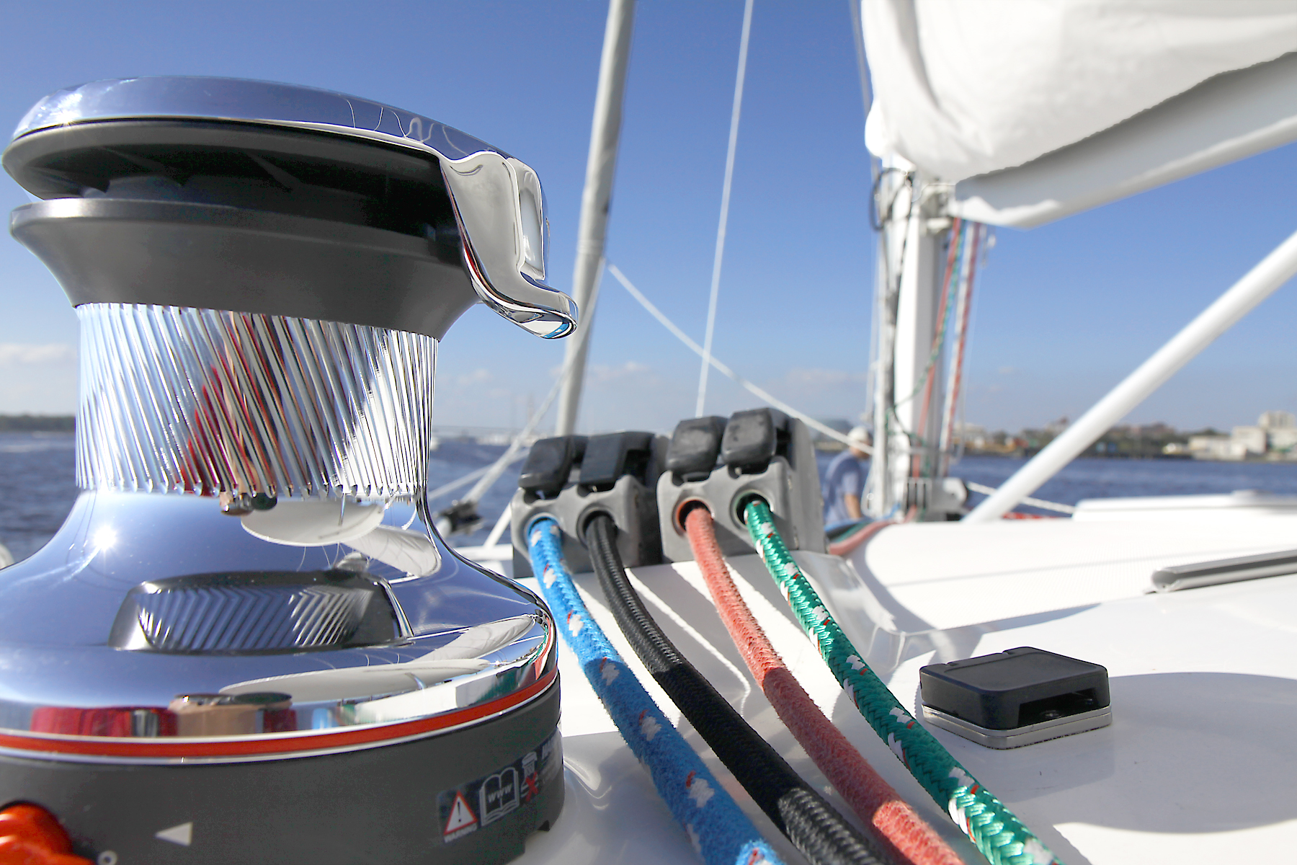
Chili Close Quarters Sailing Clinic
Ok so it wasn’t racing but Bob and Lisa made sure that if we had been they were going to have bragging rights! Great weather and a decent breeze made for a brilliant day of chasing around some buoys.
Cooler Days Sailing Challenge 2016/2017, November 1-March 31
James is dominating so far! Let’s get out and chase him down! Each time you go sailing snap a shot of any of the navigation markers you pass and email them in. The numbers are the points you will get. The most points at the end of March is the winner. The markers can only be used once per sail per day, the number does not have to be legible, don’t run aground.

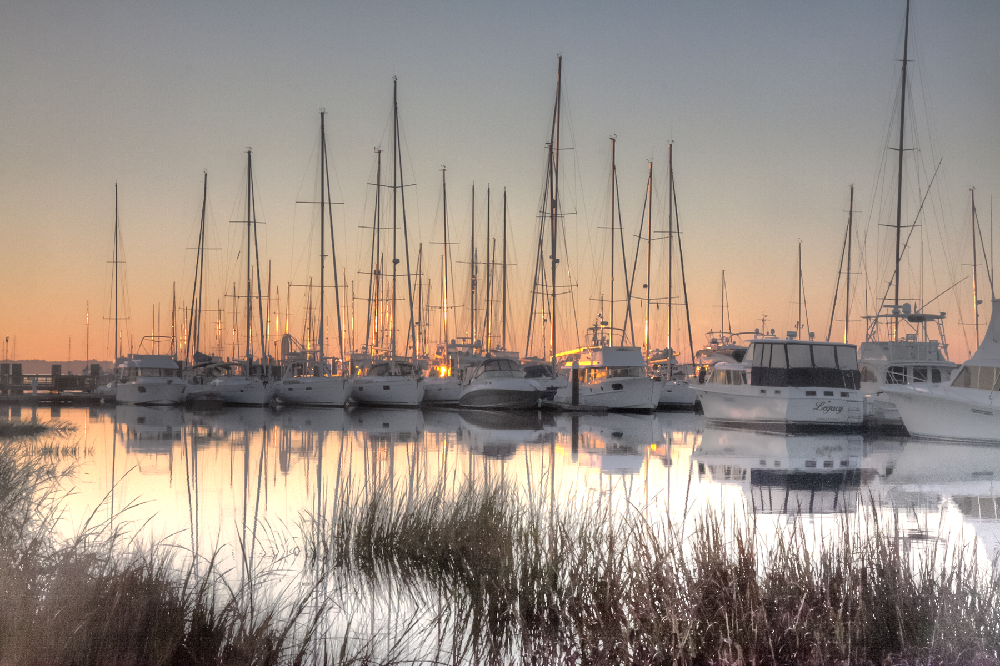

Tip of the Month
It is cooler in December, January, February but the boats, breeze and lake are still here so find the right clothes to sail in! There is no need to spend a load of money on fancy sailing gear just get a bunch of layers and a warm hat! Make sure the outer layer is wind proof and you will be toasty! If you have ski gear stashed away that is brilliant for winter sailing!

Here is a reminder of revised contact methods
- For use of Happy Sails Club boats as a member call 803 317 9060 (Brian’s cell)
- To ask for a space on an event or Sunset sail not subject to the 3-day maximum lead time call 803 317 9060 or email sail.lake.murray.sc@gmail.com
- To book ASA classes call 803 317 9070 (the “office” phone). In the near future, this will be forwarded to Lanier Sailing Academy-Atlanta on weekdays.

