The Happy Sheet
February 2017

Presidents Day Sail, Monday, February 20, 11-3
Pack a lunch and enjoy a mandatory day off! Wilana Day Sail hosted by Brian!

Winter Trivia, guaranteed to snow days. Note the time change!
February 21, March 21
Flying Saucer, meet at 6:30 for a table, Trivia starts at 7:00. Bring your non-sailing buddies! Let us know if you are coming so we can keep seats at a table!

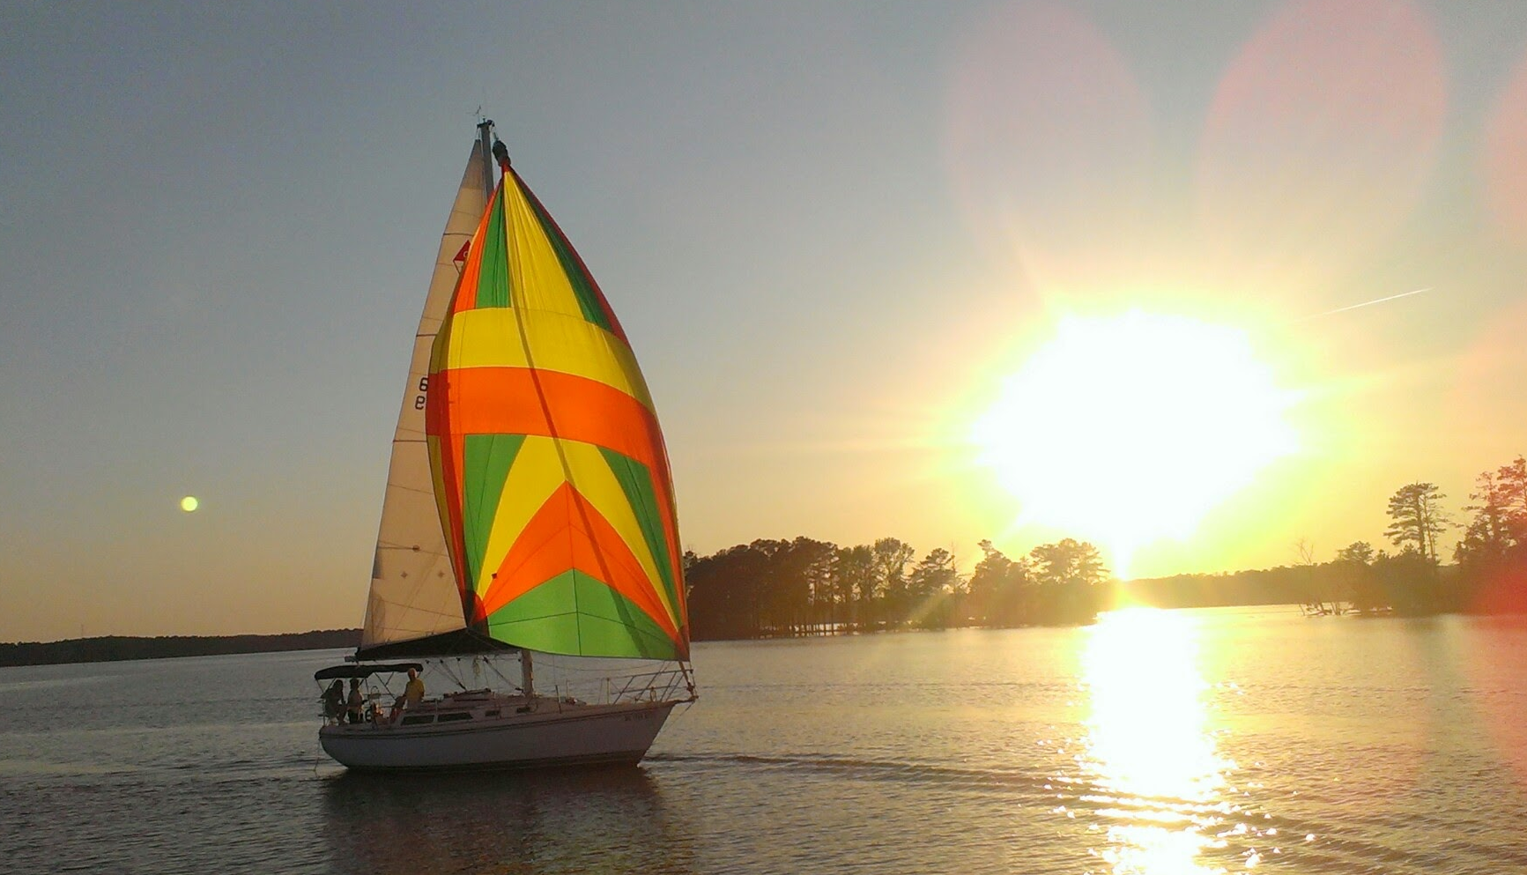
Hummin’ Bird joins the fleet! March 1, 2017
She is a Catalina 30 Tall Rig with a diesel engine and a roller furler Jib. The pictures are of her or tech specs. The rules for usage will be like Wilana’s but some of the starting and care procedures will be a little different. We will publish all that in the March Happy Sheet!

Gillian’s (Brian’s Sis) Birthday Sail, Sat. March 11, 5:30-9:00
We will take the Catalina 30 out for her first club event. Member and a guest. (no, Gillian will not be there but it is her birthday!)

Cooler Days Sailing Challenge 2016/2017, November 1-March 31
Each time you go sailing snap a shot of any of the navigation markers you pass and email them in. The numbers are the points you will get. The most points at the end of March is the winner. The markers can only be used once per sail per day, the number does not have to be legible so don’t run aground.

April Fool’s Family Sailing Day Sail and Prize Giving Cookout
Sail: 1:30-5:00, Cook Out: 5-whenever,
Celebrate everything! Spring, lighter evenings, Challenge Winners! We will do Burgers, Hot Dogs, chili sauce, cheese, and slaw! Bring your own beverage!

Eclipse Raft Up, Monday, August 21, 2017
www.eclipse2017.org has more information about the eclipse!

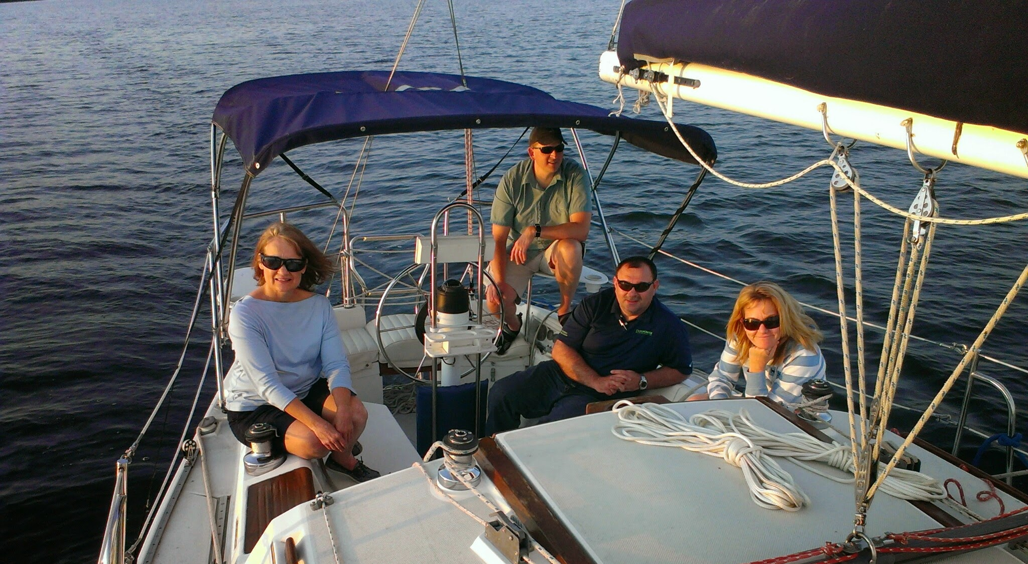

Tip of the Month

Here is a reminder of revised contact methods
- For use of Happy Sails Club boats as a member call 803 317 9060 (Brian’s cell)
- To ask for a space on an event or Sunset sail not subject to the 3-day maximum lead time call 803 317 9060 or email sail.lake.murray.sc@gmail.com
- To book ASA classes call 803 317 9070 (the “office” phone). Soon, this will be forwarded to Lanier Sailing Academy-Atlanta on weekdays.

