The Happy Sheet

March 2016

What’s New at The Happy Sails Club?
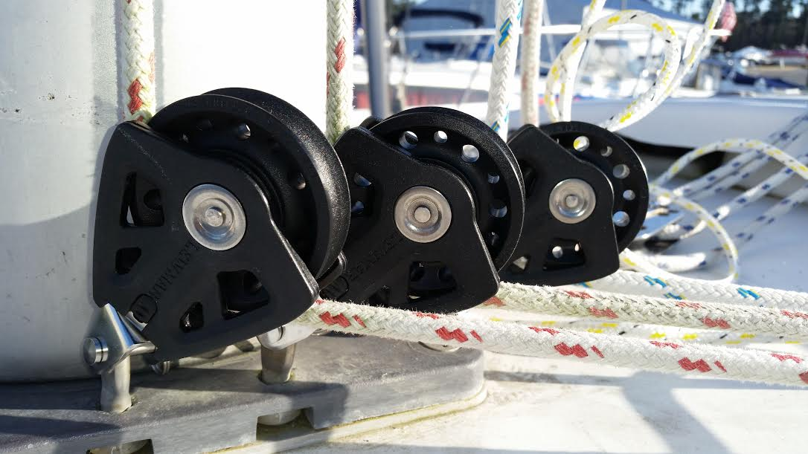
Turning blocks and lazy jacks for starters. Wilana has been improved with lazy jacks to catch the sail and blocks to help hoist and control the sails. Thanks to all who came out to the lazy jacks installation. It was a fun collaborative day!

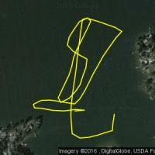
Cool Apps
James has found a couple of useful apps for the lake. The picture is from RaceQs. It will track and record your speed, etc. and then let you have cool pictures of where you went. It's free! Another one that is very cool is Navionics. You can have a full chart of Lake Murray on your device for $9.99 a year. We tried it out on our trip to the Frayed Knot and avoided the bottom a couple of times! It's like a chart plotter, only economic!

Snowstorm Trivia
Tuesday, March 22 7:15 pm at the Flying Saucer
We had a blast in February even if diamonds from Zales are not forever...... only the ones from DeBeers last that long! This may be the last one this spring, so maybe we’ll stay for the 9:30 game as well! Bring your friends. Meet at 7:15 as they start promptly at 7:30!

Wilana Green Sunset Sail
A Day Late St. Patrick’s Day Sail, March 18, 6-10
Bring your Guinness or Smithwicks for a night on the water!
I’m sure someone can come up with green cookies.

The 9th Day of April Wilana Sail
Cast off at 5:30. Return about 9:30 pm. Member and guest sail.

Workaholic Wednesdays are Back!
Wednesday, April 20 6:00 pm
The sunset is about 8 pm, so we will get boats ready at 5:30 and sail at 6:00. These are your weekday opportunities to push the envelope and try new things!

Tip of the Month:
This is a picture of a fishing lure on a sail. Brian found this while unwrapping a sail at the dock. It snagged in his hand. Luckily not to any great depth. Please be careful unwrapping the sails and handling dock lines as apparently some fisherman are not expert casters and would rather leave a lure behind than climb off their boats and unsnag them.

