The Happy Sheet

May 2016

Save some $$ with the Tip of the Month
West Marine has the lightweight manual/automatic life jackets on sale for $89.99 for the first week of May! If they sell out or the date is not exactly right, sorry!

A Tale of 3 Boats

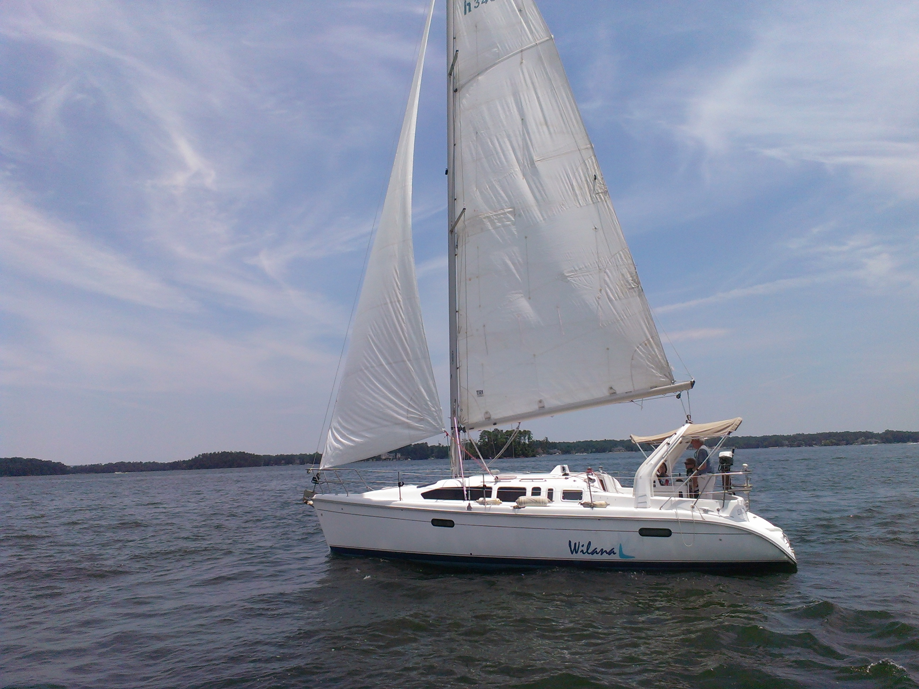
Wilana, our Hunter 340
As a Happy Sails Club member you get to sail her on Lake Murray as often as you wish for $127.33 per month after getting your Basic Coastal Cruising certification. There are a few limitations such as no night sailing etc., but there are also other club bonuses such as extra education, moonlight club sails, and other boats to sail. Unless you break something due to a lack of judgment the monthly fee is about it.

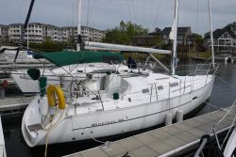
C’est La Vie
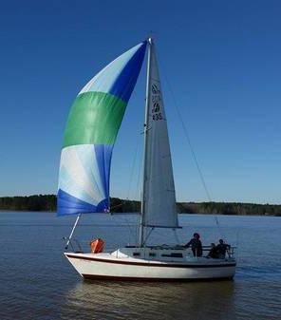
C’est La Vie is currently owned by a former Happy Sails student. He started in a Catalina 30 and then upgraded to this beautiful boat. Times change so he’s enjoying more new adventures on land these days. While the boat itself is not cheap, whoever gets it will be enjoying one of the cleanest well-kept boats I know of. Once the commitment to ownership is made the regular costs will emerge: slip rent in the $300 per month range, $300 engine tune up once a year, insurance $50 per month to start with. Even a new halyard will cost about $300 installed. http://www.yachtworld.com/core/listing/pl_boat_full_detail.jsp?slim=broker&boat_id=2955149&checked_boats=2955149&hosturl=ashleyyachts&&ywo=ashleyyachts&&ybw=&units=Feet&access=Public&listing_id=24744&url=

Swamp Fox
http://columbia.craigslist.org/boa/5519905505.html
Swamp Fox (picture on first page) is another really well kept boat on the lake. The owner is a former Happy Sails Club member. The boat is older, but has been renovated and loved. At $6000 it is a tenth of the price of C’est La Vie, but many of the running costs are similar.

Boat Ownership Disclaimer
Before I get feedback that this is all a bit negative about boat ownership and just a sales blurb for The Happy Sails Club, let me say I have privately owned boats myself and really enjoyed the ownership factor of loving MY boat. And if you have the time, money, and inclination for that amount of love I highly recommend it! In fact, it is part of the fun of running the Happy Sails Club! If Happy Sails Club members move on to boat ownership, we see that as graduation! Time with Happy Sails should confirm the love of sailing and sailboats! We will, however, welcome them back with open arms if they choose to forego the chores and the bills though.

What’s Happening

Tuesdays with Murray
May 3, 10, 17, 24, and 31
Start rigging at 6 and sail at 6:30. If the weather is awful we may try trivia instead!

Lucky Sunset Sail
Friday, May 13 6:30-10:00 pm
Will Friday the 13th be lucky for us? Sunset sail on Wilana seems lucky to us! Member and guest event.

All Day Trip for Lunch
Sunday, June 12 9:30-5:30
Leave the dock at 9:30 for a full day of sailing with a stop for lunch at The Frayed Knot, Liberty Tap, or Buffalo Creek. We will decide on the destination depending on the weather. It’ll be a fun day. Member and a guest.

