The Happy Sheet
November 2018

Bring a Buddy Cool Weather Challenge November 1-February 28
Each year we like to challenge Happy Sailors so sail more in the cooler months of the South Carolina “winter”. This time we are challengeing you to bring someone else sailing with you. You will get a point for every person you bring sailing from November 1st to February 28. You will even get a point for yourself! They can be anybody, friend, spouse, child , sibling, enemy(you do have to bring them back though!), including other Happy Sails Club Members. Prizes will be awarded!

Fall Saturday Cook Out Series, 5:30pm, November 17, 2018
We will fire up the grill on the following evenings, November 17, and December 8. BYObeverage. Burgers on the 17th!

Pop a Life Jacket Sail, 1:00-5:00pm November 25, 2018
The life jackets we use for classes are reaching the end of there life. They will be replaced on November 25. If you would like to see or feel an auto-inflatable jacket go off be at the marina at 1:00pm. We will then head out on It’s All Good for a Lazy Sunday Sail. Member and Guest Sail.

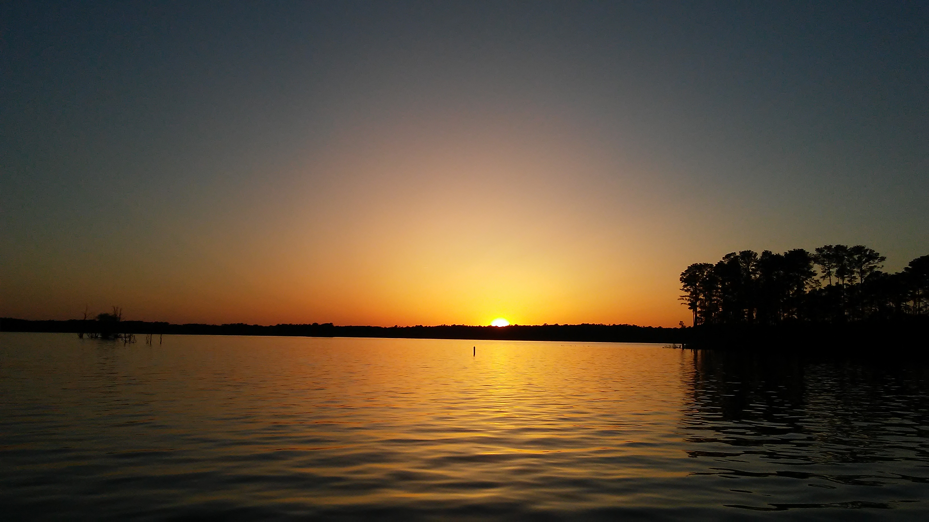

Last Minute Christmas Shopping Sail to The Frayed Knot
Sunday December 23, 9:30-5:00
Escape the season for a daysail to the Frayed Knot for lunch! Member and Guest event.

Party like it’s 2019 Sail, Jan 1, 2019 10:00-1:00
I will be in England over New Year so I am looking for a host for this clear your head sail!


Tip of the Month/Season: Get the Navionics App
The lake will be drawn down to 350’ over the month of October and through the winter. This is not a reason to stay off the lake but Navionics on your phone or pad will let you see where the shallow spots are before you find them with the keel. https://webapp.navionics.com/?lang=en#boating@15&key=ajsnEzc%60pN

The Doctors Lounge, November 8, 2018
Mitch and Liz Nimmich are Happy Sails Club Members and Doctors who support this local essential service. I have attened the last 3 years and had a blast. The Doctor bands are talented and fun! The ticket includes beverages and food, it’s hard to beat. https://www.biddingforgood.com/auction/auctionhome.action?vhost=fmc&aalias=dl2018

A slightly sexist comment follows:
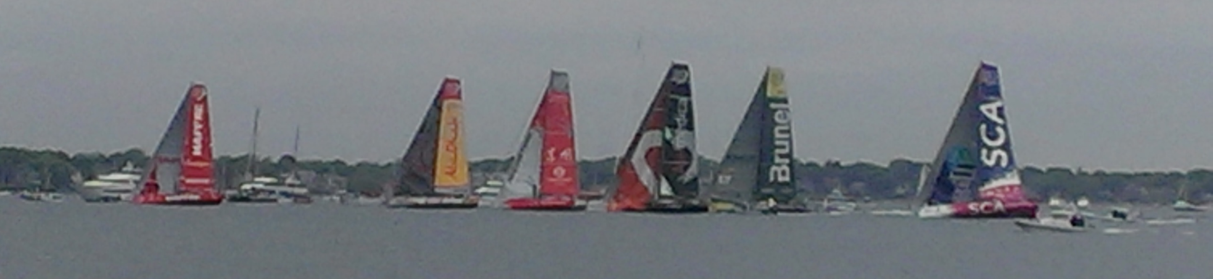
The SCA boat is crewed exclusively by women……………..apparently it is OK to heel!!

